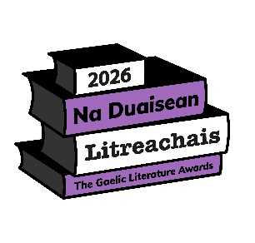
NA DUAISEAN LITREACHAIS 2026
The Gaelic Literature Awards 2026

CLÀR-IARRTAIS AIRSON LEABHRAICHEAN FOILLSICHTE

AINM AN TAGRAICHE:
SEÒLADH:
(leis a’ chòd-puist)
SEÒLADH PUIST-D:
ÀIREAMH FÒN:

Fiosrachadh mun leabhar
TIOTAL:
ÙGHDAR(AN):
DEASAICHE(AN):
EADAR-THEANGAIR(EAN):
FOILLSICHEAR:
LATHA FOILLSEACHAIDH OIFIGEIL:
(ll/mm/bbbb)
ROINN TAGRAIDH: | Tiog
  Bàrdachd
  Ficsean
  Neo-fhicsean
  Clann aois 0-7
  Clann aois 8+

Bu chòir riaghailtean agus stiùireadh na farpais a leughadh air www.gaelicbooks.org mus cuirear tagradh a-steach.

Ceann-latha airson thagraidhean: 5.00f, Dihaoine 01 Cèitean 2026
NDL@gaelicbooks.org
NA DUAISEAN LITREACHAIS 2026
The Gaelic Literature Awards 2026

ENTRY FORM FOR PUBLISHED BOOKS

NAME OF APPLICANT:
ADDRESS:
(including postcode)
EMAIL ADDRESS:
PHONE NUMBER:

Information about the book
TITLE:
AUTHOR(S):
EDITOR(S):
TRANSLATOR(S):
PUBLISHER:
OFFICIAL DATE OF PUBLICATION:
(dd/mm/yyyy)
COMPETITION CATEGORY: | Tick
  Poetry
  Fiction
  Non-fiction
  Children age 0-7
  Children age 8+

Applicants are advised to read the competition rules and guidelines available at www.gaelicbooks.org prior to submission.

Deadline for entries: 5.00pm, Friday 01 May 2026
NDL@gaelicbooks.org

